**Ideation Phase**

**Define the Problem Statements**

**Problem Statement 1:**

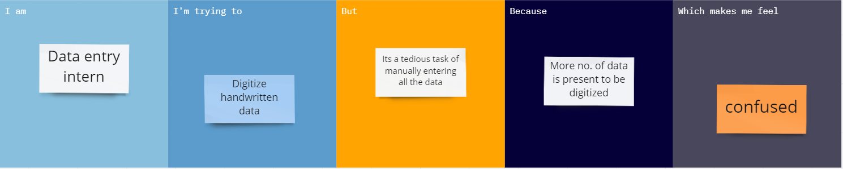

**Problem Statement 2:**

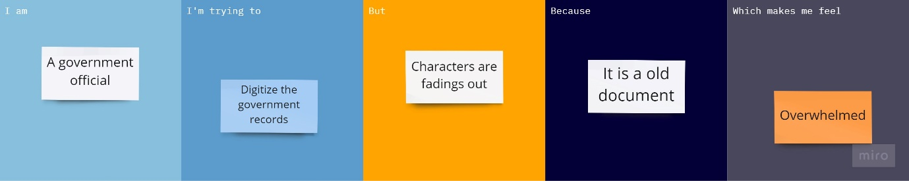

**Problem Statement 3:**

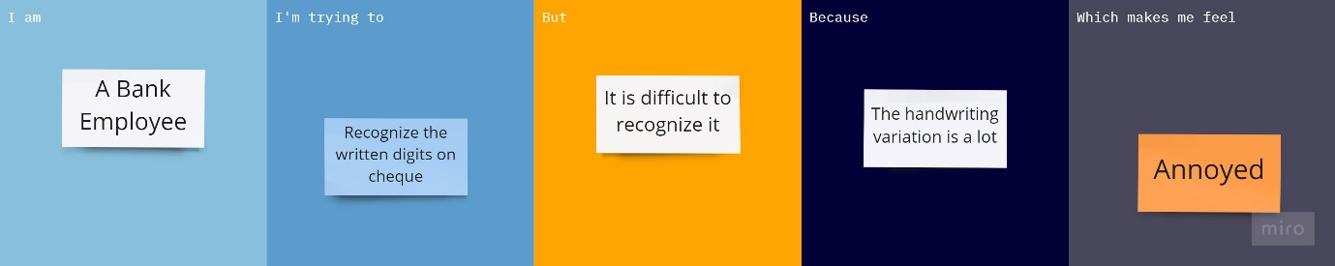

**Problem Statement 4:**

